

BRIDG Model
http://www.bridgmodel.org
Release 2.1 Readme
Biomedical Research Integrated Domain Group (BRIDG)

prepared by
BRIDG Technical Harmonization Committee (THC)

Becky Angeles (ScenPro/NCI)
Julie Evans (CDISC/HL7 RCRIM)
Smita Hastak (ScenPro/NCI/HL7 RCRIM)
Jonathan (Jay) Levine (U.S. FDA)
Charlie Mead (Booz Allen Hamilton/NCI/HL7 RCRIM)
Saurin Mehta (Novartis/CDISC)
Steven Sandberg (Mayo Clinic/NCI)
Wendy Ver Hoef (ScenPro/NCI)

23 October 2008

Table of Contents
Section 1. BRIDG Evolution 3
Section 2. What’s New in this Release 4
Section 3. Files in R2.1 Package 4

BRIDG Evolution

The releases of the BRIDG Model 2.0 and 2.1 mark an important transition point in the evolution of the BRIDG Model. Since the publication of BRIDG Release 1.0, the BRIDG Technical Harmonization Committee (THC) has added considerable new content to the model such as Adverse Events and components of Protocol Representation. In addition, the model is increasingly being used to drive application and wire-format specifications by the four stakeholders of the BRIDG Project and more organizations and project teams have gotten interested in the relevance of the shared semantics represented in the BRIDG Model. All members of the BRIDG community benefit from this increase in both the ‘breadth’ (content) and ‘depth’ (application/implementation of BRIDG semantics) of the BRIDG Model.

However, this increase in the breadth and depth of the BRIDG Model has also resulted in a model that is increasingly difficult for domain experts to understand as a result of the attempts of the THC to represent as much sub-domain-specific verbiage as possible while still maintaining underlying semantic consistency (a balancing act that has been accomplished through the use of the BRIDG ‘pillars’ and multiple UML stereotypes which also makes it more difficult to non-ambiguously map to the HL7 RIM, a primary requirement of the BRIDG Model).

As a result, the THC and the BRIDG Board of Directors have formulated a strategy to manage this increase in complexity. Although the specifics of the solution to be adopted are not yet completely worked out, the BRIDG community can expect a reformatted model that will most likely involve two ‘layers’ rather than the single layer now in evidence. In particular, there will most likely be an ‘upper layer’ of multiple sub-domain models (e.g. Protocol Representation, Study Conduct, Analysis, Adverse Events, and Common Components) in which each sub-domain will be much more ‘user friendly,’ and a second, ‘lower’ level which will be a single robust model with the appropriate conventions to ensure non-ambiguous RIM mapping. A rough sketch of the evolution strategy looks something like this:

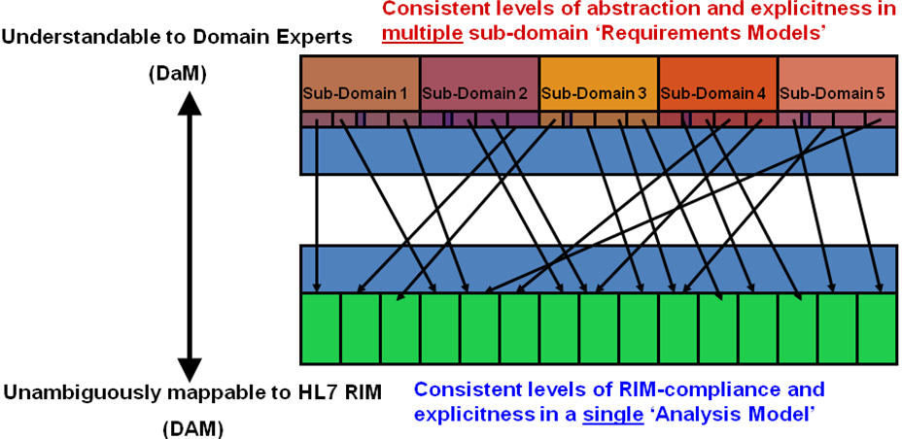

What’s New in this Release
BRIDG Release 2.1 contains new semantics to support:
- Clinical Trial Registries – includes both the World Health Organization (WHO) and clinicaltrials.gov registries
- Protocol Abstraction
- Eligibility Criteria (draft)

These semantics are an important step towards a computable protocol representation.

In addition to the new semantics, BRIDG Release 2.1 will also use HL7 V3 R1 data types instead of ISO data types which will position the model to evolve to RIM compliance in BRIDG Release 3.0.

Files in R2.1 Package
This BRIDG Release 2.1 package contains the following files:

- BRIDG Release 2.1.EAP
- BRIDG Release 2.1 Static Elements Report.RTF
- BRIDG Release 2.1.xmi
- BRIDG Release 2.1 Readme.doc (this document)

